Муниципальное казенное общеобразовательное учреждение
"Шилягинская средняя общеобразовательная школа"

Подготовила и провела:
учитель английского языка
МКОУ "Шилягинская СОШ"
Ильясова Эльмира Махмудовна

Шиляги-2021 г

Цели: развивать иноязычную коммуникативную компетенцию,
совершенствовать общекультурную компетенцию.
Задачи : Образовательные:развивать умения строить высказывания в монологической речи в контексте коммуникативной задачи ;развивать умения в диалогической речи.
Воспитательные: создать комфортную среду для каждого ученика,
воспитать у учащихся уважение к историческим и культурным памятникам страны изучаемого языка;
-воспитать уважение к собеседника.
Развивающие:
-развивать лингвострановедческую компетентность учащихся и их познавательную активность;
-развивать творческое воображение;
-развивать память;
-расширять кругозор;
-совершенствовать организационные навыки и умения работать в -сотрудничестве.

Ход урока

1. Организационный момент.

I’m glad to see you today. I’m happy to work with you, our topic is very interesting and exciting, because we are going to take a trip to one of the most beautiful countries of Europe. I want you to be positive, I want you to be in a high spirit today, I hope you’ll get bright impressions about our meeting. I do my best to make our lesson memorable and interesting. Of course, I need your help to do our lesson more productive and useful. Today I want to find out how smart you are, how many interesting facts about Great Britain you know and how cooperative you can be.

2. Фонетическая зарядка.
Children, how many seasons do you know? (Слайд 5-6)

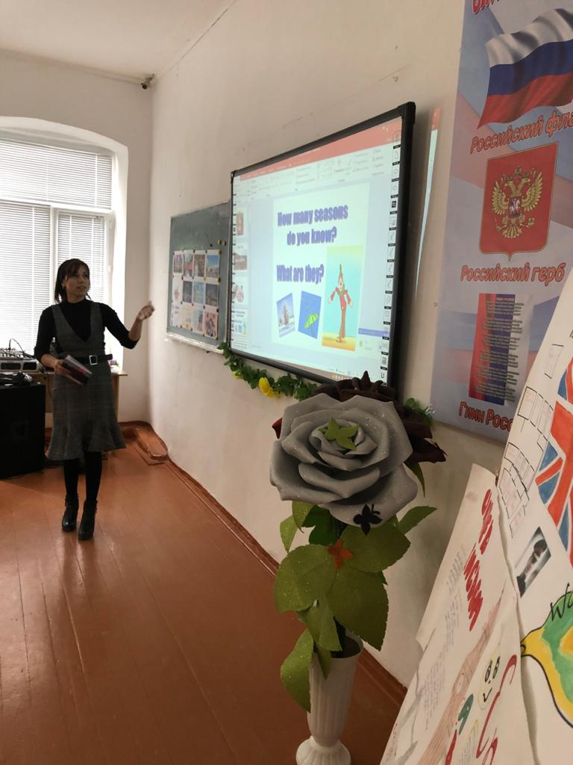

3.Собщение новой темы.

The theme of our lesson for today is " Great Britain" (Слайд 7)

Every country has its own anthem. Now we’ll listen to the British anthem “God Save the Queen”, a national patriotic song which is used for important events in Great Britain.

The Queen is Head of State of the UK and 15 other Commonwealth realms. The elder daughter of King George VI and Queen Elizabeth, she was born in 1926 and became Queen at the age of 25, and has reigned through more than five decades of enormous social change and development. The Queen is married to Prince Philip, Duke of Edinburgh and has four children and eight grandchildren.(Слайд 8).

1) Просмотр видеозаписи гимна Великобритании “God Save the Queen”. (Слайды 8- 9).
1. God save our gracious Queen,
Long live our noble Queen,
God save the Queen:
Send her victorious,
Happy and glorious,
Long to reign over us:
God save the Queen.
2. Lord, our God, arise,
Scatter her enemies,
And make them fall.
Confound their politics,
Frustrate their knavish tricks,
On Thee our hopes we fix,
God save us all.
3. Thy choicest gifts in store,
On her be pleased to pour;
Long may she reign:
May she defend our laws,
And ever give us cause
To sing with heart and voice
God save the Queen.



Teacher: And now children I will tell you a little about The Prime Minister. What do you know about him?(Слайд 10).
The Prime Minister of the United Kingdom of Great Britain and Northern Ireland[3] is the head of Her Majesty's Government in the United Kingdom. The Prime Minister (informal abbreviation: PM) and Cabinet (consisting of all the most senior ministers, who are government department heads) are collectively accountable for their policies and actions to the Monarch, to Parliament, to their political party and ultimately to the electorate. The current Prime Minister, David Cameron, leader of the Conservative Party, was appointed by the Queen on 11 May 2010.

4. Достопримечательности Великобритании.

And now we will talking with you about the sights of the UK. (Слайды 11-23)

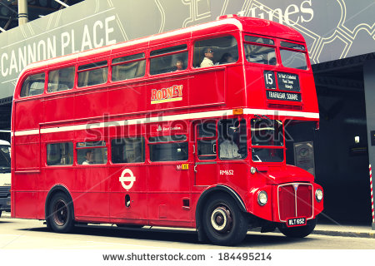
A double-decker bus is a bus that has two storeys or decks. Double-decker buses are used for mass transport in the United Kingdom, Europe, Asia and many former European possessions an iconic example being the red London bus. Double-decker buses are also used in many other cities around the world.
Early double-deckers put the driver in a separate cab. Passenger access was via an open platform at the rear, and a conductor would collect fares. Modern double-deckers have a main entrance door at the front, and the driver takes fares, thus halving the number of bus workers aboard, but slowing the boarding process. The rear open platform, popular with passengers, was abandoned for safety reasons, as there was a risk of passengers running and jumping into the bus.

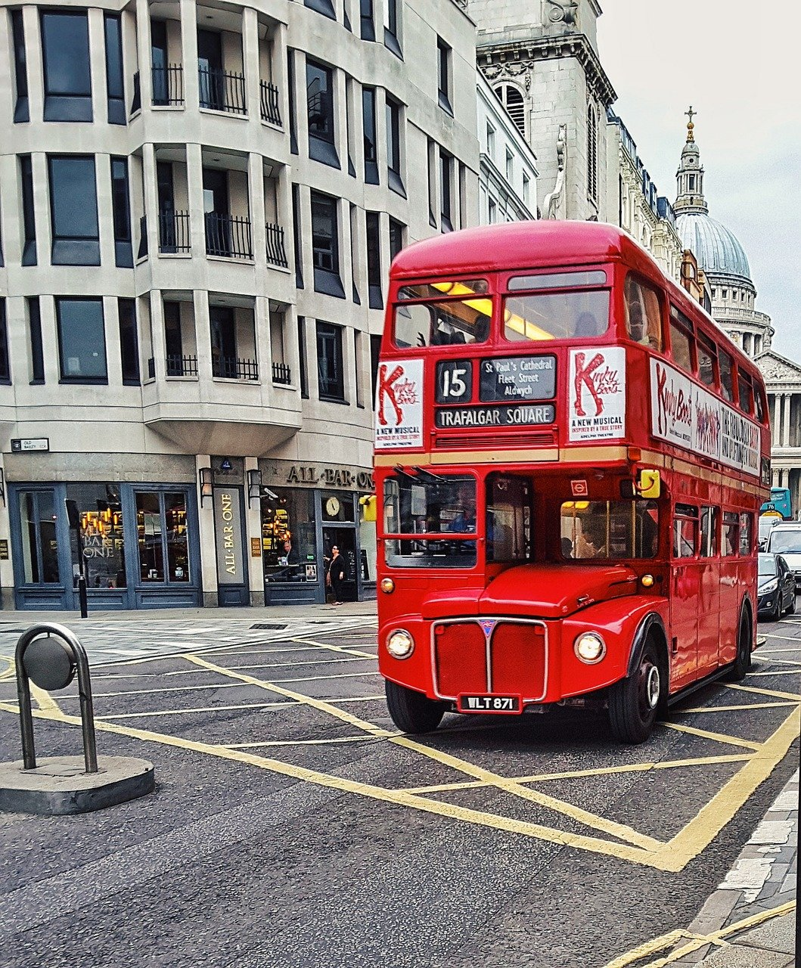

Букингемский дворец (Buckingham Palace)

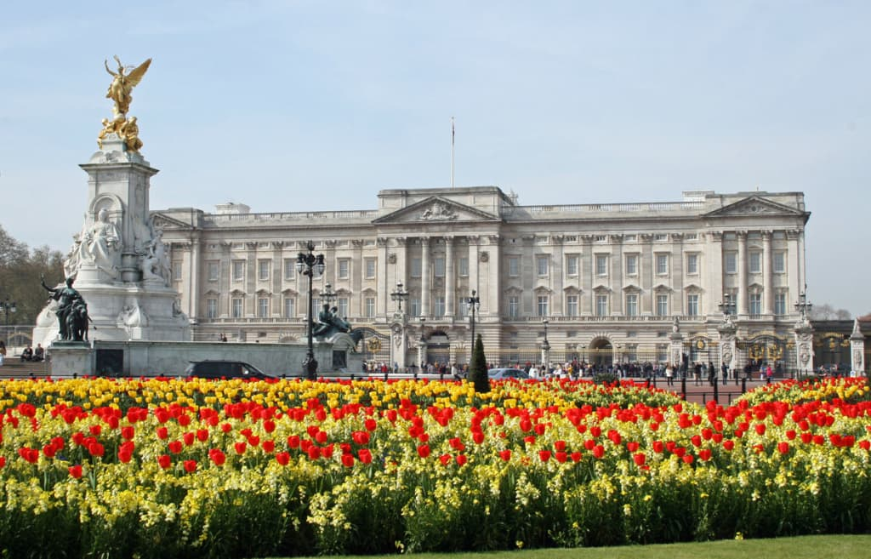

With its architecturally defined profile, this is one of London’s most popular historical buildings. Buckingham Palace was built in 1703 for the Duke of Buckingham. Later restored by Nash, the present facade was planned by Sir Aston Webb in 1913. At the west end of the Mall, Buckingham Palace is the London residence of the Sovereign.
When the Queen is here, the royal standard flutters over the palace. The Royal Mews, in Buckingham Palace Road, house the coaches and horses used on all state occasions and are open to the public on Wednesday and Thursday. The Queen’s Gallery, also in Buckingham Palace Road; has especial exhibitions from the Royal collection and may be visited every day except Monday. In its entirety, the Palace and the beautiful gardens which surround it occupy an area of approximately 40 acres. Altogether this is one of the most interesting places in London for the tourist.
The ceremony of the Changing of the Guard that takes place daily at eleven o’clock in the morning. Every day a large crowd of people gather to see this famous and traditional ceremony. It is an event that, in spite of its regularity, appears to be a solemn classical ritual, of purely British flavour.
Buckingham Palace is not only the royal residence: it’s a small city under one roof. It has a cinema, a post-office, some caffees and a restaurant, a hospital and even a night club. More than 700 people work here every day.

Биг-Бен (Big Ben)

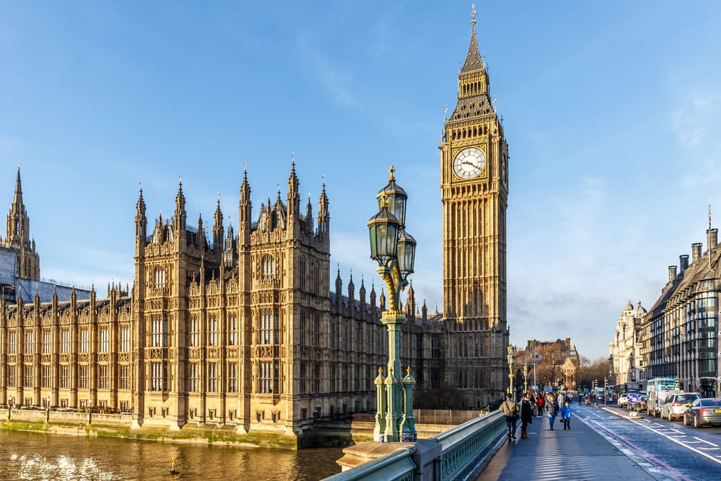

Big Ben is a bell in the clock tower at the Palace of Westminster in London. There are two versions of the origin of the name of the tower. The first version says that Big Ben was named after Sir Benjamin Hall, who ran the casting of the bell. Another says that the heariest bell at the moment (13.7 tonns) got its name after Benjamin County, a very famous boxer in the heavyweight division at the time.
Construction. The tower was built on the design of English architect Augustus Pugin in 1858. For the first time the clock was wound on May 21, 1859. Officially, the tower was named as «The Clock
Tower of Westminster Palace».
Managing the Clock. When the clock on the tower rush or lag (the error is small — only 1.5-2 seconds) an old English penny is placed on the pendulum. Putting or a coin the superintendent manages to get the precision of the machinery. Now Big Ben is one of the most famous constructions of the UK.
Источник: https://sprint-olympic.ru/uroki/anglijskij-jazyk/78971-dostoprimechatelnosti-velikobritanii-spisok-osnovnyh-mest-s-nazvaniiami-na-angliiskom-iazyke-s-perevodom-na-rysskii-iazyk-foto-chem-znamenita-angliia.html

«Westminster Abbey» (Вестминстерское аббатство).

London is a place where many historic buildings and tourist attractions are situated. Westminster is considered to be a political centre of the city where many offices are placed. However, the main part of Westminster is obviously the Abbey. It is located near the Houses of Parliament.
Westminster Abbey is a place where all English kings and queens were crowned and Royal wedding ceremonies took place. In addition, many royalties and great people are burried there: Queen Elizabeth I, William Shakespeare, Charles Darwin, Isaac Newton, Bernard Show, Lord Byron, Walter Scott and many others.
According to the ancient tradition, the church was founded by St.Peter 900 years ago. Later it was rebuilt during the reign of Henry III. The original Westminster Abbey was built in the Romanesque style and then it was reconstructed in the Gothic style. The church is very high and has a magnificent exterior.
Every year the church attracts millions of people who come there to see the Abbey and visit the famous Poet’s corner. There is also a statue of Shakespeare there which appeared in 1741. Therefore, Westminster Abbey is an interesting place to visit. You can admire the glory of the church and see the tombs of outstanding people there.

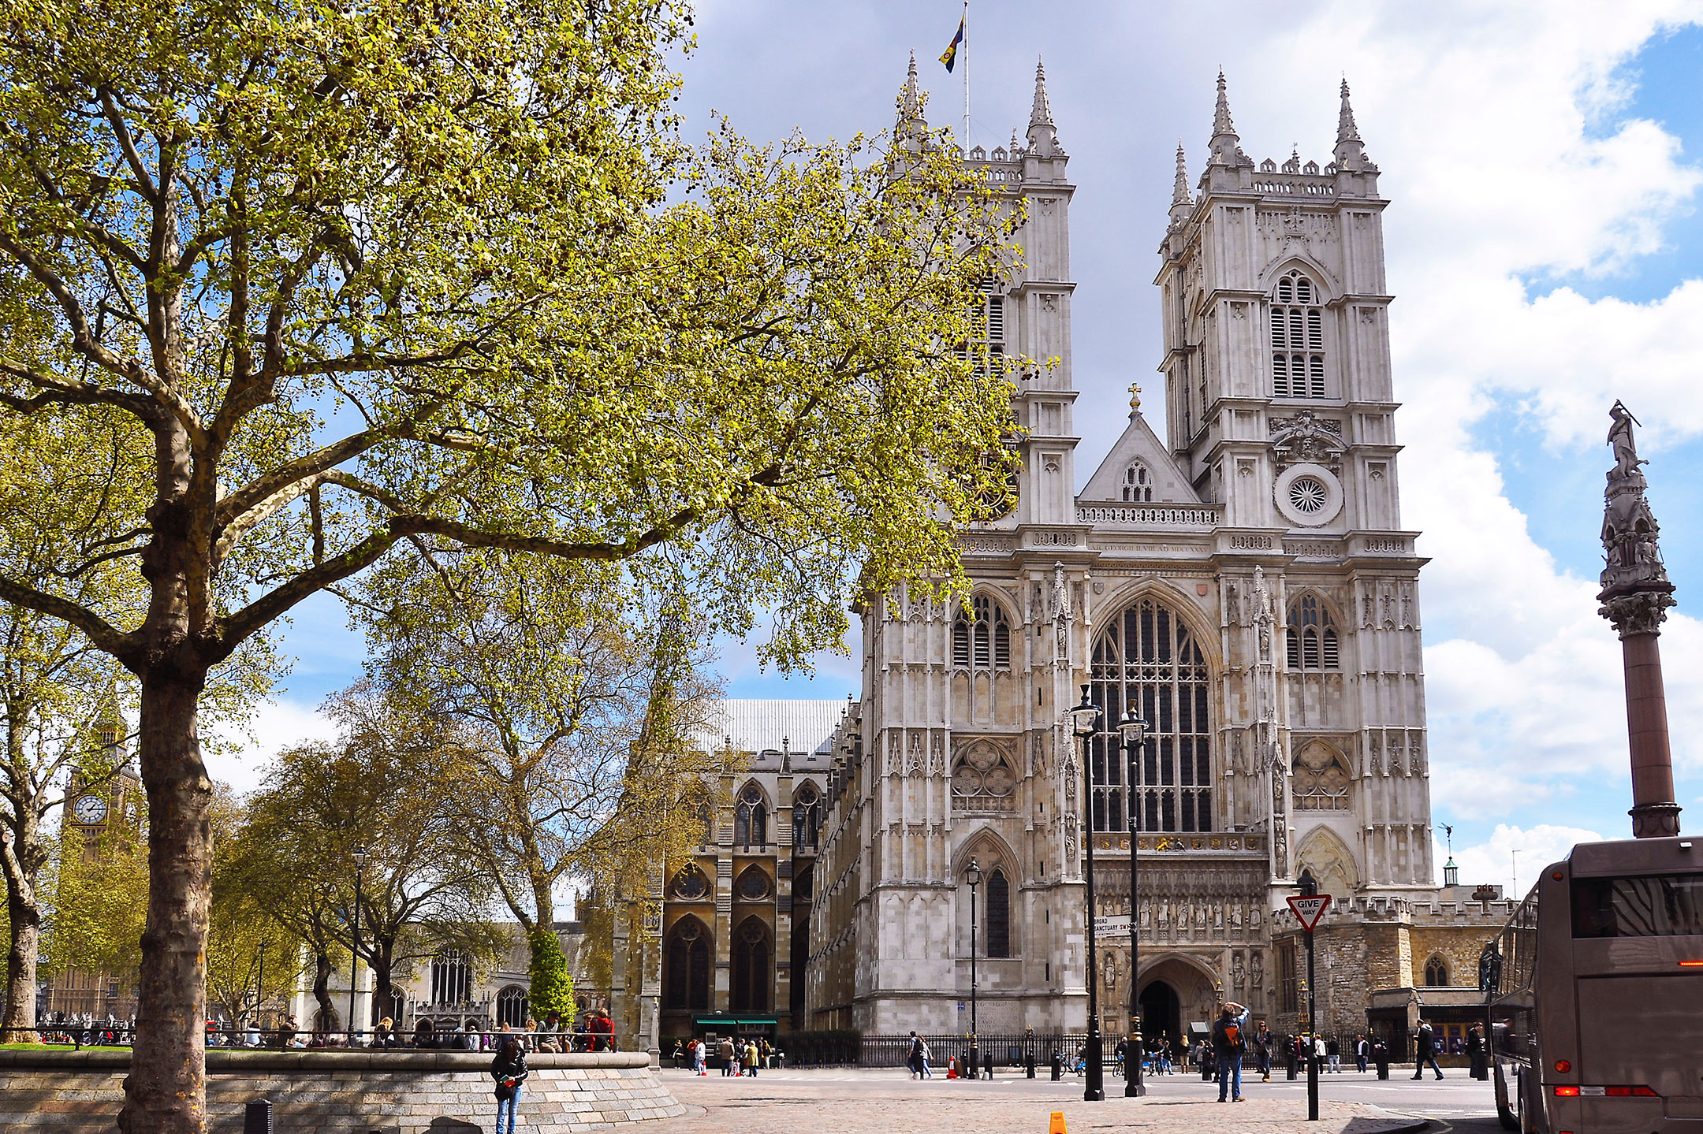

Teacher: And now we’ll speak about the most famous British group “The Beatles”. Слайд (24).
What do you know about this group ?

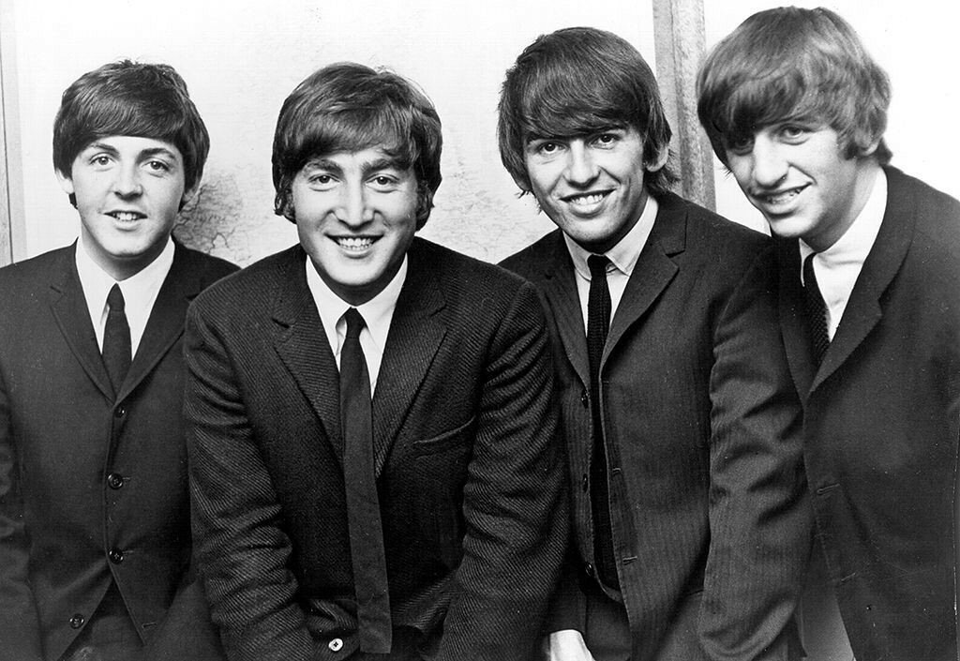

The Beatles were a legendary English rock band, which was established (признана) in 1959 in Liverpool. The group consisted (включает в себя) of John Lennon, Paul McCartney, George Harrison and Ringo Starr. This was not the original composition (состав группы) of the group but those whom the entire world (весь мир) knows as THE BEATLES!
In 1963, the band began climbing to the world recognition (мировое признание) and created a global phenomenon (мировой феномен) called Beatlemania. The quartet (квартет) has become the first British band, which have had records (пластинки, музыкальные записи) which gained popularity (приобрела популярность) and also gained first place in the U.S. charts (чарты, хит-листы). In the list (рейтинг) of Rolling Stone 500 the first place was occupied by the music album Sgt. Pepper’s Lonely Hearts Club Band. The group has also won seven Grammy awards.
The most popular songs of the Beatles are «Yesterday», «Let it be», «Yellow submarine», «Obladi-Oblada», «Girl», «Come Together», «Hey, Jude!».
The Beatles had a profound influence (большое влияние) on rock music and are recognized (признанный) by experts as one of the most successful (успешный) groups of the XX century. This group has changed the lives of many people. I personally believe that their music will never die and will continue to be played for generations (поколения) to come!

5. Физминутка.(Слайд 26-27).

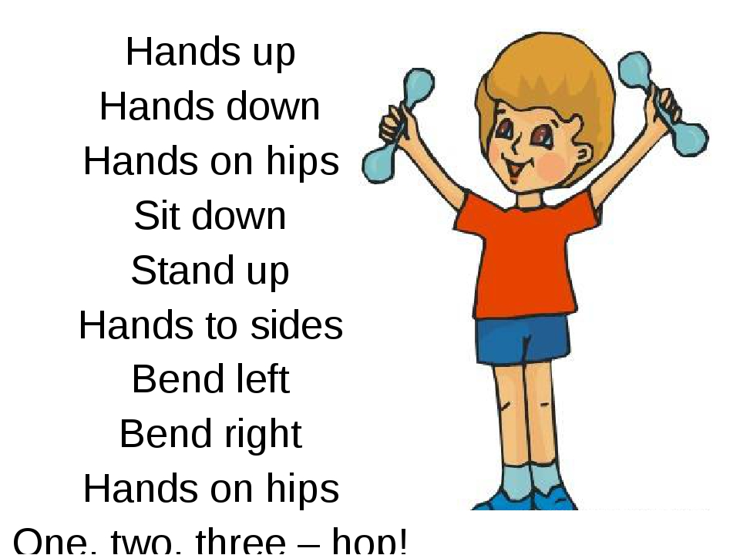

6. Традиции и обычаи Англичан. (Слайд 28-29).

Тeacher: So, every country and nation has their own traditions and customs. It's very important to know traditions and customs of different people, especially if we want to know their language. We can't say: " we know English", if we do not know English traditions. Besides, they are very important in the life of English people. They are proud of their traditions and keep them up carefully. That's why we are going to know more about British holidays today.
As we know there are several holidays in the year. And today we'll talk about only late-autumn, winter and early-spring holidays in Britain and traditions connected with them.
And, now, the first game. Look at the blackboard, please, and find the right date for every holiday:
January, 1 | Easter
April – May | New Year
February, 14 | Thanksgiving Day
December, 25 | St. Valentine's Day
November,26 | Hallowe'en
October,31 | Christmas

PI: We celebrate New Year on the 1st of January.
P2: Easter is celebrated in April or May.
P3:etc
Т.: Thank you. Very good! I will tell you about Hallowen.

Traditionally on Halloween Night people wear scary or funny costumes of witches, vampires, pirates, fairies and ghosts. The most popular children's amusement on Halloween is "trick-or-treating".
They visit houses in their neighbourhood knocking on every door yelling the phrase: "Trick or treat!" Usually people give them sweets, fruit and candies, but if they don't, the children can play a low-down trick on them.
Another famous All Saints’ Night tradition is making Jack O'Lantern: people carve a scary smiling face on a pumpkin and put a candle inside.
Traditional Halloween symbols are bats, black cats (and white ones in England), spiders, ghosts and images of Jack O'Lantern.

Halloween is celebrated all over the world
Halloween is celebrated in many countries all over the world. In some of them (China, Mexico, Austria) the dead are honored and welcomed: people leave food and gifts for the souls of their deceased loved ones and keep lights in their houses burning all night.
In other countries, like Germany, people are afraid of ghosts and spirits. They even hide knives and other sharp objects in order not to be hurt by these visitors on Halloween night.
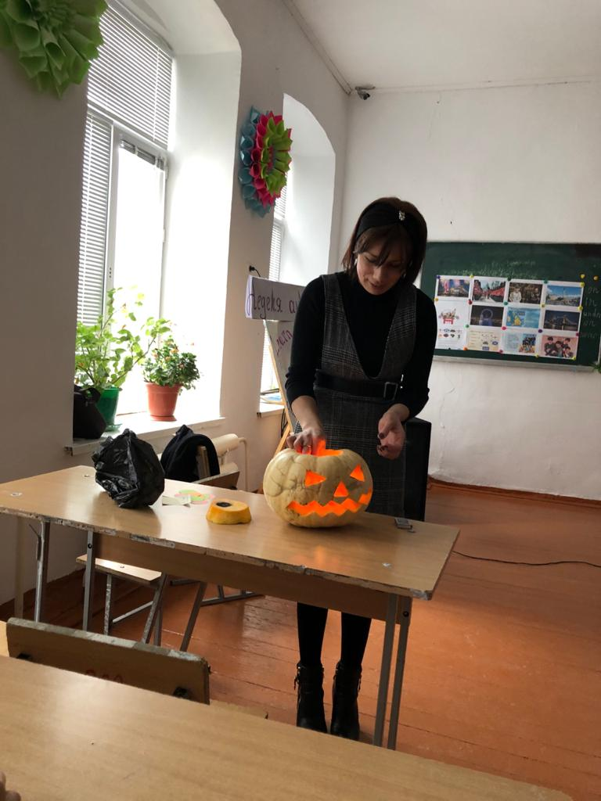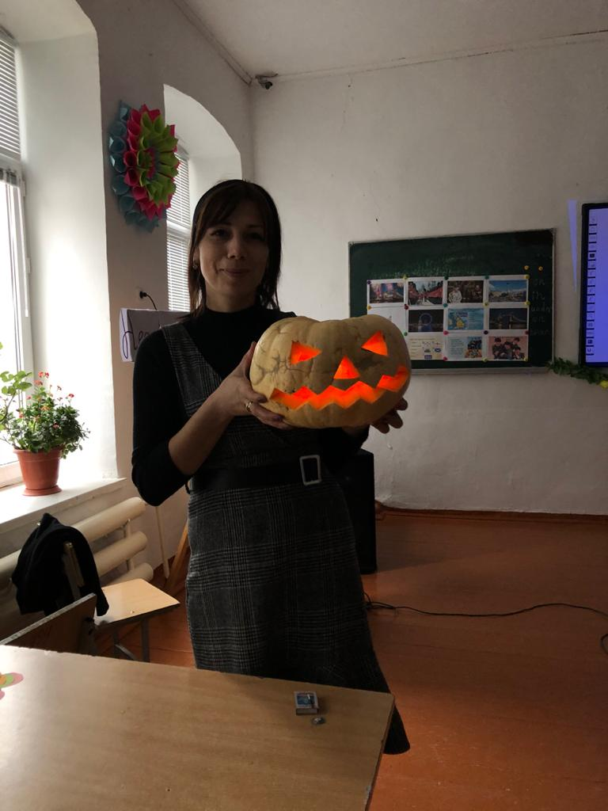

Easter
From Scotland to the Channel, Britain is full of customs and traditions. A lot of them have very long histories. Some are funny, some are strange- But they're all interesting and are all part of the British way of life.
Easter is the time for holidays, festivals and time for giving chocolate Easter eggs, the day of parties, and above all a celebration that Jesus raised from the dead and lives forever. Eggs play an important part in Easter celebration; they are predominantly given to children. The eggs are either hollow or have a filling, and are usually covered with brightly colored silver paper.
Easter is much more than ordinary holiday. It is the oldest and the most important Christian Festival, the celebration of the death and coming Jesus Christ to life again. For Christians, the dawn of Easter Sunday with its message of new life is the high point of the year.
Easter is a feast that is not always held on the same date each year. Easter Day is celebrated on the first Sunday following the first full moon after the spring equinox.
This means that Easter can fall as early as March 22 or as late as April 25.
Like most Christian festivals, Easter has its origins in pre-Christian times. Our ancestors believed that the sun died in winter and was born anew in spring. The arrival of spring was celebrated all over the world long before the religious meaning became associated with Easter. Today, Easter celebrates the rebirth of Christ.
The word Easter is thought to have derived from the goddess Eostre, an Anglo-Saxon Goddess.
Even though Easter is associated with spring here in England, it is not so in countries in the Southern Hemisphere. In these countries Easter falls near the end of autumn. However, through out the world Easter is felt to be a time of new life and new beginnings.

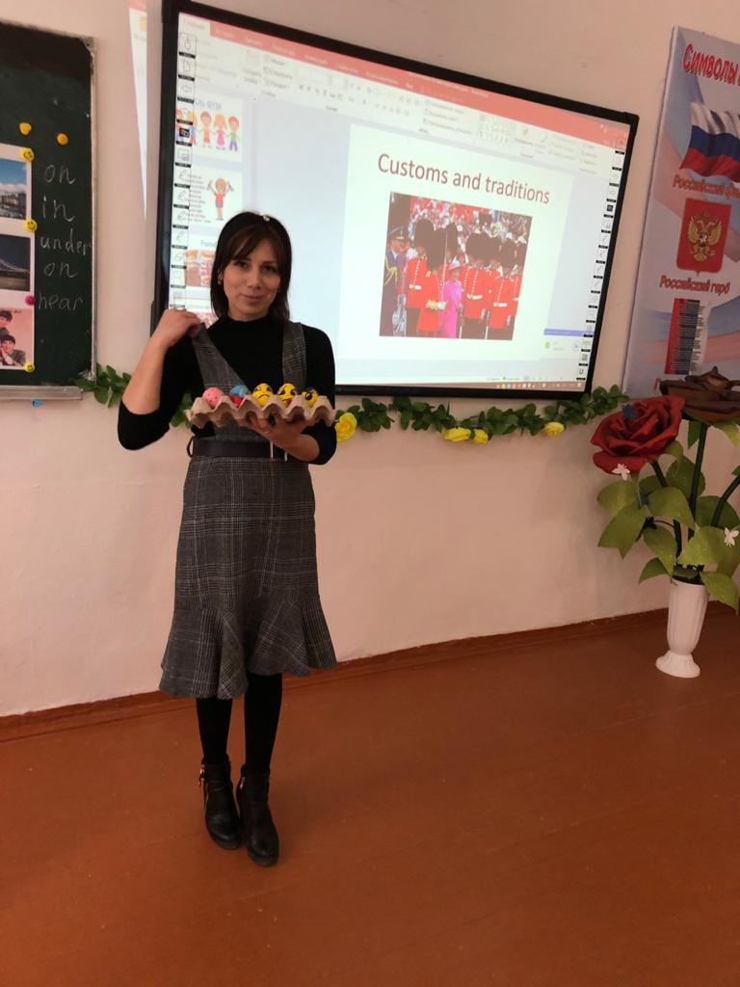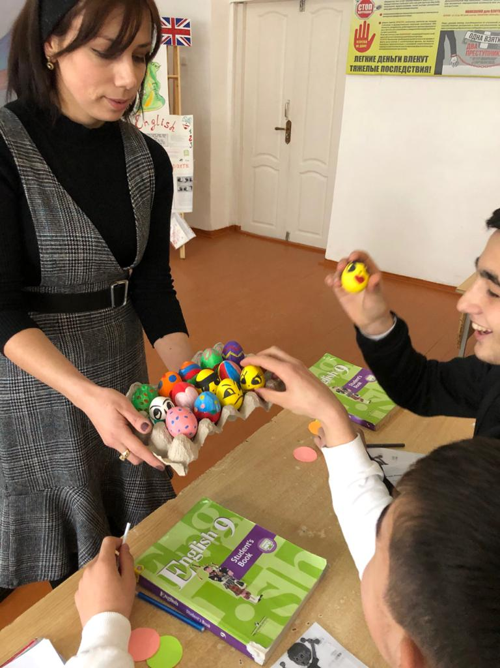

Traditionally the English drink tea six or seven times a day: in bed, at breakfast, at lunch, during the day and at 5 o'clock. Why is tea drinking so popular? Let's try to answer .

Tea is the Most Popular Drink in Britain .
Everyone knows that tea is the most popular drink in Britain. It's even more popular than coffee, which is favoured throughout Europe and America.
The Dutch brought the first tea to Europe in 1610. But it was not until 1658 that the first advertisement for tea appeared in a London newspaper. At that time a pound of the cheapest tea cost about one-third of a skilled worker's weekly wages. Tea was guarded by the lady of the house and kept in special containers, often with a lock and carefully doled out by the teaspoon.
By 1750 tea had become the principal drink of all the classes in Britain. Later, tea-drinking developed into a fashionable social ritual. Tea parties were popular at home and soon the ritual of "afternoon tea" was firmly established.
Nowadays, throughout the homes, tea shops and hotels of Britain, the custom of tea-time continues. Tea in Britain is brewed in a teapot. Then the one spoonful of tea per person and one for the pot is added.
Most people in Britain prefer a rich, strong cup of tea with milk, and sugar is sometimes added to taste to this question.

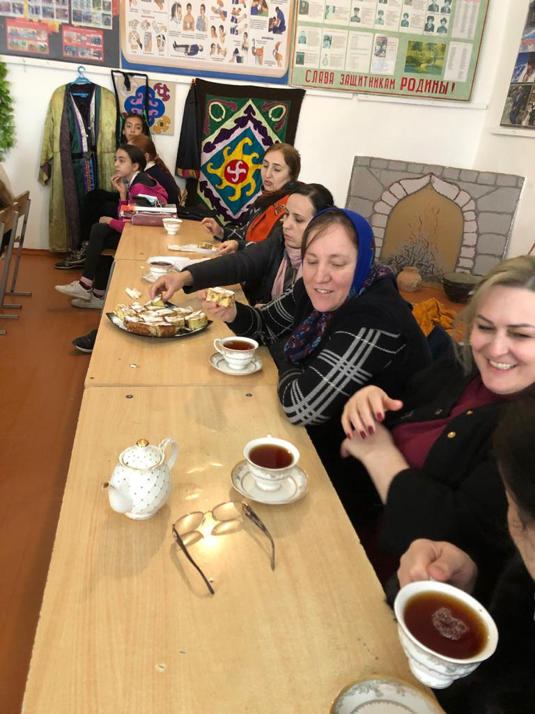

7. Грамматические задания.

Выберите и поставьте вместо пропуска правильный вариант.(Слайд 31).

Complete the sentences. ( valley, lake, country, river, sea, lake, mountain, coasts, beaches, capital)
1. Great Britain is an __________________ .
2. It's divided into three _____________ : England, Scotland and Wales.
3. London is the_________________ of England and the United Kingdom (Great Britain and Northern Ireland).
4. The ___________________ Thames runs right through the city.
5. In summer many British people spend their holidays by the __________ .
6. England has some nice holiday resorts with lovely sandy ____________.
7. But there are also steep _____________ , like in Dover or Folkestone for example.
8. If you want to see Nessie, then you must go to the famous British ___________ , Loch Ness.
9. It is in Scotland and so is Great Britain's highest ______________ , Ben Nevis.
10. If you climb Ben Nevis and the weather is fine, you will have a wonderful view over the _____________ below.

Выберите правильный ответ. (Слайд 32-33)

1. The capital of the UK is…
Belfast;
Cardiff;
London.

2. You can see waxen figures of different famous people in…
National Gallery;
Madam Tussaud’s Museum;
the Tower of London.

3. The highest mountain in Great Britain is…
Ben Nevis;
Snowdon;
Snowpeak.

- The population of the UK is…
45 ml. people;
57 ml. people;
60 ml. people.

- The longest river in Great Britain is…
The Thames;
The Clyde;
The Severn.

6. The colours of the British Flag are…
White, blue, green
White, blue, red
Blue, red, yellow

7. The name of a famous stadium in England where football matches take place is…
Wimbledon;
Wembley;
Luzhniki.

8. A double-decker is…
A car;
A train;
A bus

8. Вопросы к учащимся по новой теме. (Слайд 35).

1. What is the capital of Great Britain?
2. What is the Symbol of England?
3. What do you know about the Daffodil?
4. Who is the Queen of the United Kingdom ,of Great Britain and Northern Ireland?
5. What is the Union Jack?

9.Символы Великобритании. Слайды(36-38).

National Emblems of the United Kingdom

The United Kingdom (abbreviated from "The United Kingdom of Great Britain and Northern Ireland") is the political name of the country which consists of England, Scotland, Wales and Northern Ireland (sometimes known as Ulster).
Great Britain is the name of the island which is made up of England, Scotland, Wales, whereas the British Isles is the geographical name of all the islands off the north-west coast of the European continent. In everyday speech "Britain" is used to mean the United Kingdom.
The flag of the United Kingdom, known as the Union Jack, is made up of three crosses. The upright red cross on a white background is the cross of the 1st George, the patron saint of England. The white diagonal cross on a blue background is the cross of St. Andrew, the patron saint of Scotland, The red diagonal cross on a white background is the cross of St. Patrick, the patron saint of Ireland.
The Welsh flag, called the Welsh dragon, represents a red dragon on a white and green background.
St. George's Day falls on 23 April and is regarded as England's national day. On this day some patriotic Englishmen wear a rose pinned to their jackets'. A red rose is the national emblem of England from the time of the Wars of the Roses (15th century).
St. Andrew's Day (the 30th of November) is regarded as Scotland's national day. On this day some Scotsmen wear a thistle in their buttonhole. As a national emblem of Scotland, thistle apparently first used in the 15th century as a symbol of defence. The Order of the Thistle is one of the highest orders of knighthood. It was founded in 1687, and is mainly given to Scottish noblemen (limited to 16 in number).
St. Patrick's Day (the 17th of March) is considered as a national day in Northern Ireland and an official bank holiday there. The national emblem of Ireland is shamrock. According to legend, it was the plant chosen by St. Patrick to illustrate the Christian doctrine of the Trinity to the Irish.
St. David's Day (the 1st of March) is the church festival of St. David, a 6th-century monk and bishop, the patron saint of Wales. The day is regarded as the national holiday of Wales, although it is not an official bank holiday.
On this day, however, many Welshmen wear either a yellow daffodil or a leek pinned to their jackets, as both plants are traditionally regarded as national emblems of Wales.
In the Royal Arms three lions symbolize England, a lion rampant — Scotland, and a harp — Ireland. The whole is encircled and is supported by a lion and a unicorn. The lion has been used as a symbol of national strength and of the British monarchy for many centuries. The unicorn, a mythical animal that looks like a horse with a long straight horn, has appeared on the Scottish and British royal coats of arms for many centuries, and is a symbol of purity.

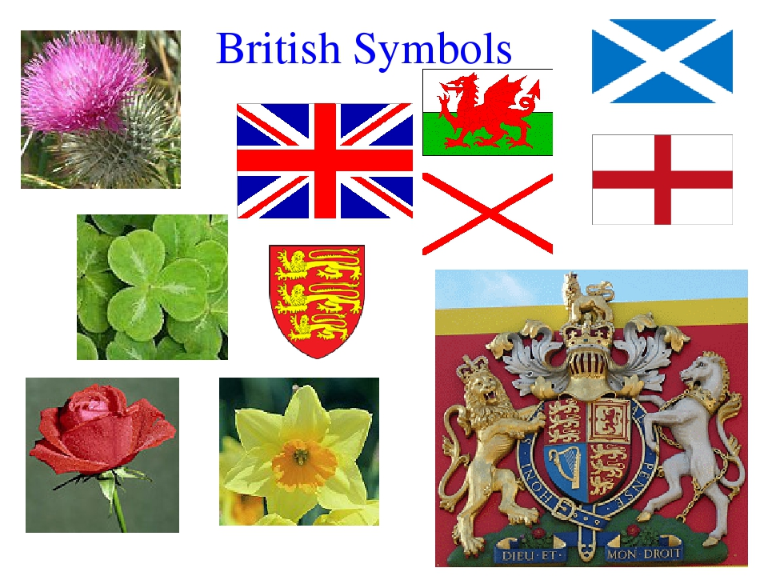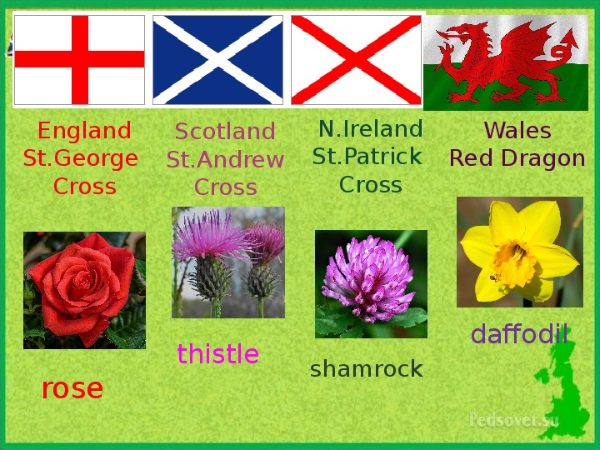

The National Symbol of Wales / Государственная эмблема (Национальный символ) Уэльса-НАРЦИСС.

Wales has got two national symbols. These are the daffodil and the leek.
They are both connected to the Patron Saint of Wales.
According to the legend, during a battle against the Saxons, St. David advised his soldiers to wear leeks in their hats so that they could easily be distinguished from their enemies.
Another link between the leek and St. David is the belief that he had to live on bread and wild leek for several years.
However, today each year on St. David's Day the leek is worn in the cap badges of every soldier in every Welsh regiment.
But outside the army, many other Welsh people have substituted the leek by the daffodil, perhaps because it looks more attractive and certainly smells a lot better.
The daffodil is also associated with St. David's Day, due to the fact that it breaks into blossom on that day. Interesting to note that one of the many Welsh names for a daffodil is "Cenhinen Bedr" which means "Peter's leek".
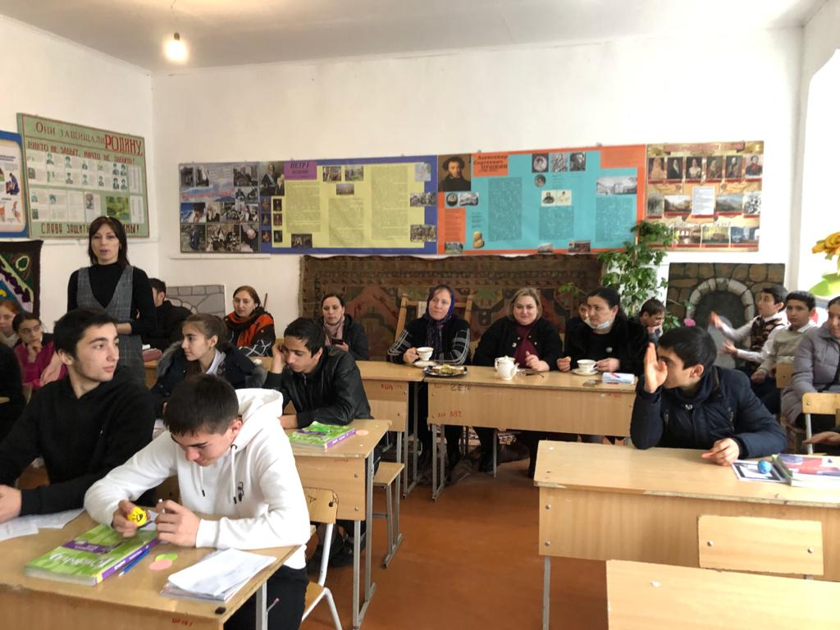

10. Устные задания.(Слайды 39-40).

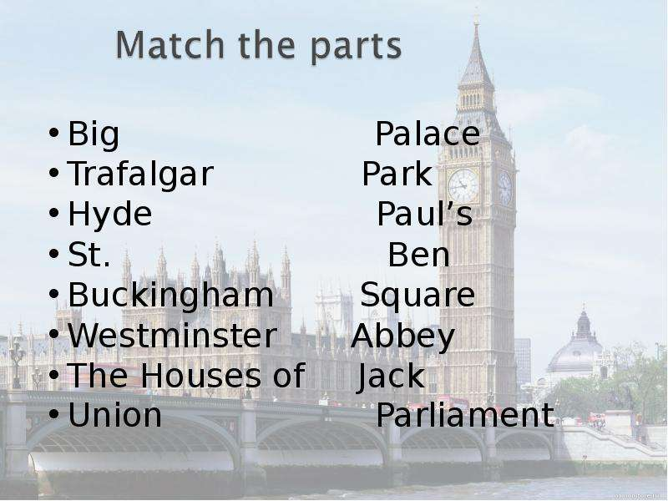

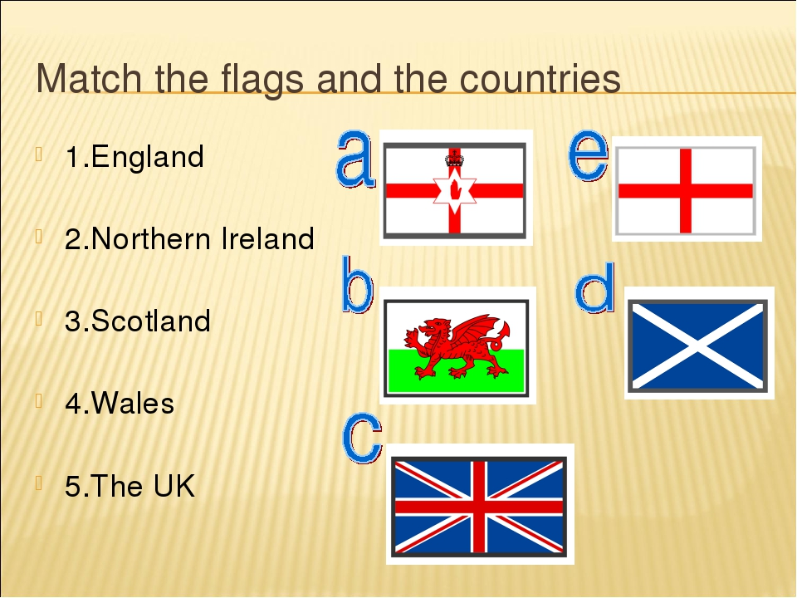

Прочитайте текст и выполните задание.(Слайды 41-42).

Places to visit.
London is the capital of England. It is its political and business centre. City is the oldest part of London. There are many banks and offices there. You can visit some interesting places in the city. One of them is the Tower of London. The Tower of London was a fortress, a palace, a prison. Now it is the museum. One of the greatest English churches, St. Paul`s Cathedral, is not far from the Tower of London. The famous English architect, Sir Christopher Wren, built it in the 17 century. It is a beau
tiful building with many columns and towers. The centre of London is Trafalgar Square. It is the most beautiful place in London. In the middle of the square stands a tall column. It is a monument to Admiral Nelson. There are two beautiful fountains in the square. Every day many tourists visit Trafalgar Square.

№ | Statements | True/False
1 | London is the capital of England. | true
2 | Many people live in the City. | true
3 | St. Paul`s Cathedral is very far from the Tower. | false
4 | Tower isn`t a museum. | false
5 | Tower of London Was a fortress and a prison. | true
6 | The famous English architect Sir Christopher Wren built the Cathedral in the 17th century. | true
7 | Trafalgar Square is not in the centre of London. | false
8 | In the middle of the square stands a tall column of Admiral Nelson. | true

11.Рефлексия. (Слайд 44).
Thank you for such an interesting and exciting lesson. It was really great. I am very glad that you are interested in English. Good bye children.

